Isa’s & pipelining

Designing instruction set architectures
Factors to consider when looking at different ISAs:
- Instruction length – What is the number of bits per instruction?
- Numer of explicit operands per instruction – Do we use a stack or one or more registers? How many addressable registers are there?
- Type, size and location of operands
- Memory organisation – Is the memory byte- or word-addressable?
- Addressing modes available – Is the addressing direct, indirect or indexed?
- Types of operations available – What do the instructions actually do?
In choosing an ISA, the main measures we care about are:
- Main memory space occupied by a program – RAM is expensive, so typically smaller is better.
- Instruction complexity and length – More complex instructions are more complex to process
- Total number of instructions in the instruction set – Do we want many instructions?

Endianness
Bye ordering, or endianness, is another major architectural consideration.
If we have a two-byte integer, we have achoice in how the least significant byte and most significant byte are stored.
- In little endian machines, the least significant byte is followed by the most significant byte.
- In big endian machines, the most significant byte is followed by the least significant byte.
Address | 00 | 01 | 10 | 11
Big Endian | 12 | 34 | 56 | 78
Little Endian | 78 | 56 | 34 | 12

Big Endian:
- Is more natural.
- The sign of the number can be determined at the byte at address offset 0
- Strings and integers are stored in the same order
Little Endian:
- Makes it easier to place values on non-word boundaries
- Conversion from 16-bit integer address to a 32-bit one does not require any arithmetic.

Register architectures
The next consideration for ISA design concerns how the CPU will store data.
The choices are:
- Stack architecture
- Accumulator architecture
- General purpose register architecture
In choosing between these, the trade off is between:
- Simplicty (and cost) of hardware design
- Execution speed and ease of use

In a stack architecture, instructions and operands are implicitly taken from the stack.
- A stack cannot be accessed randomly
In an accumulator architecture, one operand of a binary operation is implicitly in the accumulator
- One operand is in memory, creating lots of bus traffic.
In a general purpose register (GPR) architecture, registers can be used instead of memory
- Faster than accumulator architecture
- Results in longer instructions
Most systems today are GPR systems. There are three types:
- Memory-memory where two or three operands may be in memory.
- Register-memory where at least one operand must be in a register
- Load-Store where no operands may be in memory.
The number of operands and the number of available registers direct affects the instruction length.
Stack machines use one- and zero-operand instructions.
- Instructions implicitly operate on elements at the top of the stack.
  - Push X and Pop X instructions require a single memory address operand.
  - Binary instructions (e.g., Add, Mult) use the top two items on the stack.
Stack architectures require us to think about arithmetic expressions a little differently.
- We are accustomed to writing expressions using infix notation. Stack arithmetic requires that we use postfix notation.
Z = X + Y
turns into
Z = X Y +
The main advantage of using postfix notation is that parentheses are not needed.
Z = (X * Y) + (W * U)
turns into
Z = XY* WU* +
In a stack ISA, it would look like this:
Load X
Mult Y
Store TEMP
Load W
Mult U
Add TEMP
Store Z
Note that the result of a binary operation is implicitly stored on the top of the stack!

In a two-address ISA, (e.g. Intel, Motoral) Z = (X * Y) + (W * U) looks like this:
Load R1, X
Mult R1, Y
Load R2, W
Mult R2, U
Add R1, R2
Store Z, R1
Note that two address ISAs usually require one operand to be a register.
With a three-address ISA (e.g. mainframes) Z = (X * Y) + (W * U) looks like this:
Mult R1, X, Y
Mult R2, W, U
Add Z, R1, R2

Instruction types
Instructions fall into several broad categories that you should be familiar with:
- Data movement
- Arithmetic
- Boolean
- Bit manipulation
- I/O
- Control transfer
- Special purpose.

Addressing
Addressing modes specify where an operand is located.
- They can specify a constant, a register or a memory location.
The actual location of an operand is its effective address.
- Certain addressing modes allow us to determine the address of an operand dynamically.
We can choose between the following types of addressing:
Immediate The data is part of the instruction
Direct The address of the data is given in the instruction
Register The data is located in a register
Indirect The address of the address of the data is given in the instruction
Register Indirect Uses a register to store the address of the data
Indexed Uses a register (implicitly/explicitly) as an offset, which is added to the address in the operand to determine the effective address of the data.
Based Similar to indexed, except that a base register is used instead of an index register.

Pipelining
Some CPUs divide the fetch-decode-execute cycle into smaller steps.
- These smaller steps can often be executed in parallel to increase throughput
Such parrallel execution is called instruction-level pipelining.
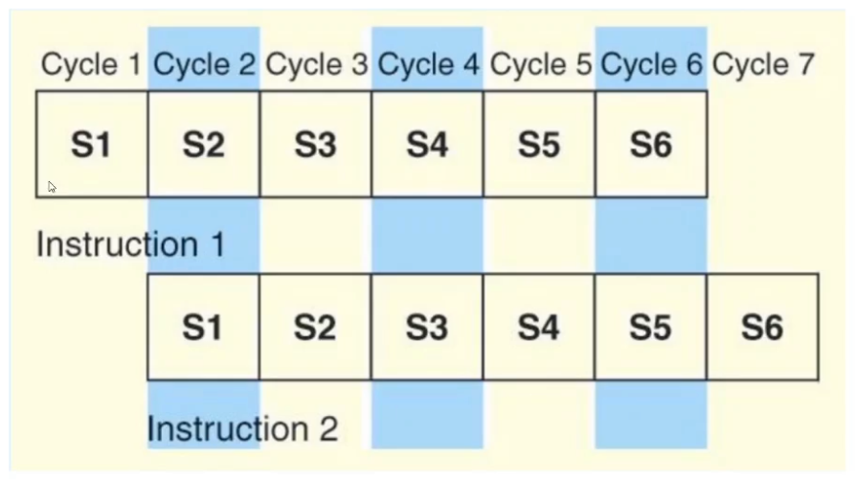
Suppose an FDE cycle were broken into the following smaller steps:
S1 Fetch instruction
S2 Decode opcode
S3 Calculate effective address of operands
S4 Fetch operands
S5 Execute instruction
S6 Store result
We can then use this as a six stage pipeline.

The theoretical speed up offered by a pipeline can be determined as follows:
- Each instruction represents a task, T, in the pipeline. Let N be the number of tasks in the program
- Let t_{p} be the time per stage and K the number of stages in the pipeline
- The first task T1 requires Kt_{p} time to complete
- The remaining (N – 1) tasks emerge from the pipeline one per cycle.
- So the total time to complete the remaining tasks is (N – 1)t_{p}.
Thus, the time needed to complete N tasks using a K-stage pipeline is
Kt_{p} + (N – 1)t_{p} = (K + N – 1)t_{p}

The speedup is therefore
Nkt_{p} / (K + N – 1)t_{p}
If we take the limit as N –> [infinity] then (K + N – 1) –> N
Therefore,
S_{infinity} = Kt_{p} / t_{p} = K

Our neat equations takes a number of things for granted.
For example, we assume that…
- ...the architecture supports fetching instructions and data in parallel
- ...the pipeline can be kept filled at all times
This second case may not always be true.
Pipeline hazards are things that can cause a pipeline to stall, or be flushed for any of the following reasons:
- Resource conflicts
- Data dependencies
- Conditional branching
Measures can be taken to reduce the effects of these hazards, both at the software level and at the hardware level, but they cannot be totally eliminated.

